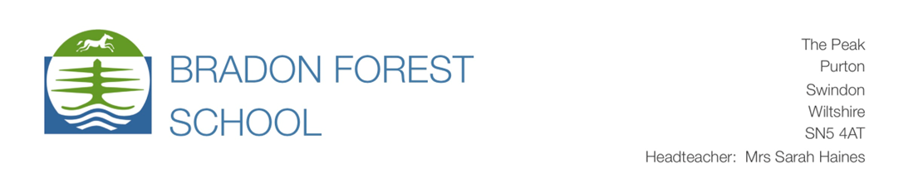

November 2024

Dear Parents
VISIT TO USA - Friday 14 February – Thursday 20 February 2025
I write to update you about our visit to the USA. I will issue a final letter in January, but some useful information is included here, including details of how to apply for ESTAs.
HOTELS
We will be staying at the Comfort Inn Downtown, in Washington DC from Friday 14 February to Sunday
16 February 2025. The hotel is located near to the White House and Franklin Square.
Link to website: Hotel in DC | DC Downtown Hotel - Comfort Inn Downtown DC/Convention Center
We are staying at the Springhill Suites, in Chelsea, New York, from Sunday 16 February to Wednesday
19 February 2025. The hotel is located near to Madison Square, in the flower district. The hotel is part of the Marriott chain of hotels.
Link to website: Hotels in Chelsea NYC | SpringHill Suites New York Manhattan
The WASHINGTON DC Hotel Address ONLY (below, in bold) is required to carry out the ESTA application detailed next. The application asks for your US Point of Contact Information; please enter this hotel address and phone number as follows:
Comfort Inn Downtown DC/Convention Center
1201 13th Street NW, Washington, DC 20005
Telephone: (202) 682-5300

MEDICAL CONDITIONS
Please ensure we are made aware of any medical conditions or requirements for your child as soon as possible. Your child may not be covered by the insurance if you have not disclosed any previous medical conditions that arise on our visit, which then require treatment in the USA. In some cases, parents have been requested to take out further insurance for students with certain medical conditions. If you have any concerns about this, please contact us as soon as possible.
In some cases, it will be useful for us to arrange a meeting with parents to talk through their child’s medical needs, both physical and mental, so we are better prepared to deal with any issues that might arise on the trip. If there is something that might affect your child’s health and wellbeing on the trip, we are keen to be able to support them. Please do email me if you would like to meet with me to discuss anything. I may be in touch with parents directly where students have specific medical conditions listed on our school records. This will enable me to carry out a risk assessment and ensure that we have arrangements in place to best care for your children when we are away.
ESTAs
The majority of students travelling to the USA with us will require a visa waiver, called an ESTA (Electronic System for Travel Authorisation), which you must apply for online using the web address below.
https://esta.cbp.dhs.gov/esta/
If students already have an ESTA, it is valid for two years from the date of issue. Please ensure that your child’s ESTA is still going to be valid for our trip in February 2025. If necessary, details will then need to be updated via the same web address above.

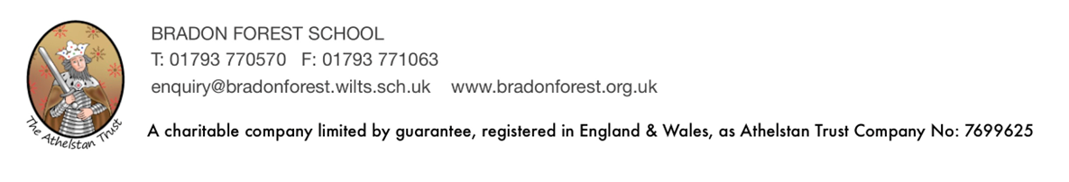

You must ensure you access the correct ESTA site. You will see the words “Official Website of the Department of Homeland Security” in the top left corner. Beware of others who will charge for processing your application. The only cost to you should be the $21 for the ESTA, which is charged to you when you apply online via the site above. You will need to carry out this application yourselves, and in good time for our visit – submitting the details to Miss Cole by Wednesday 8th January. In most cases, you will receive authorisation immediately. However, in a few cases, it has been known to take a few days. If this happens, to confirm your child’s ESTA has been approved, you will need to go back to the ESTA site and use the application number to check the status of your application. If authorisation is denied for any reason, a visit to the US Embassy and a face-to-face interview in London is needed to obtain a non-immigrant visa. It can take several weeks for an appointment slot, so it is important that we avoid this by applying early. Please check the application carefully. Mistakes made in the application for the ESTA will mean that your child will be unable to fly to the USA if the details in their passport do not match with the details entered for the ESTA, as this renders the ESTA invalid. This is checked when we check in for our flights. The school will not make these checks on your behalf.
To carry out the application, you will need your child’s passport handy, as the first stage of the process requires that you scan or upload a photograph of the photo page of the passport. You may wish to scan the photo page in advance of starting the application, so that you can then upload the document to the website. It may be necessary to use a scanning app to get a clear picture, such as HP smart. This can be downloaded from Google Play Store. The scan/photo must include all of the information, including the numbers to the bottom of the photo page. You will not be able to proceed with the application until this has been carried out successfully.
You will then need to use our hotel address in Washington DC for the section asking for your address while in the US. (your US point of contact)
Comfort Inn Downtown DC/Convention Center
1201 13th Street NW, Washington, DC 20005
Telephone: (202) 682-5300

Once you have your child’s ESTA confirmed, please email ccole@bradonforest.wilts.sch.uk with the Application Reference Number (given at the end of the application process) AND print and submit a paper copy to Miss Cole as soon as the application is completed and approved. Students will need to hand this to Miss Cole in H7 during morning registration. Please also print a copy for your own reference. Your child will need to bring it with them on the visit. If students already have an ESTA, you will need to update the US point of contact information online. Please submit the updated ESTA to us as soon as possible.
The deadline for ESTAs is Wednesday 8th January 2025 at the latest. Please ensure you submit these by then.
If your child is not a UK passport holder, you will need to check on entry requirements and visas to the USA at the following web address, as you may need to apply for a tourist visa, for which there will be a fee. Below are some useful weblinks where you can find out more. It is your responsibility to arrange this for your child. Please do let us know the details once you have done so.
Visa Waiver Program | U.S. Customs and Border Protection
Requirements for Immigrant and Nonimmigrant Visas | U.S. Customs and Border Protection
FLIGHTS
Our flights are as below.
Departure  Friday 14 February 2025  London Heathrow-Washington IAD 12.25pm  (Arrive 4.06pm USA time)  Virgin Atlantic-VS021 | Return  Wednesday 19 February 2025  New York JFK-London Heathrow  20.45 (land on Thursday 20th 08.45 UK time)  Virgin Atlantic-VS138

Our flight times will require an early start from school, so we estimate we will depart Bradon Forest by coach at approximately 6am on Friday 14 February. We will return to school on Thursday 20 February at approximately 12 noon. We will confirm more accurate times in the final letter and at the parent meeting on 14 January 2025.
BEHAVIOUR – a reminder
Residential trips require students to demonstrate responsible and acceptable behaviour. The success of these visits is based on trust. A proviso in the initial letter states *The school reserves the right to exclude a student from going on a trip when the student has misbehaved on a previous trip, or whose general behaviour in lessons and around school has been persistently below the standard expected, and when a student could be seen as a risk to their personal safety and the safety of others. In these circumstances all payments that can be recovered will be refunded less an administration fee of £50. Where fees have been incurred which cannot be recovered (for example for flights/visas and accommodation) the school will not make a refund.”
Therefore, students not demonstrating responsible and acceptable behaviour in school will be monitored closely. If we deem that your child’s behaviour raises concerns, this could have implications for them being able to take part in the visit. To this end, we will be monitoring the behaviour of the students taking part throughout the next school year. If we are concerned about your child’s behaviour prior to the trip, we will ask to have a meeting with you to discuss this. If there isn’t an improvement in the behaviour, their place on the trip could be at risk.
The school procedures for managing this are outlined below.
If a student is at risk of being removed from a trip due to poor behaviour, staff will contact Mrs Haines as soon as possible.
Stage 1: The list of students going on the trip is checked with the Head of Year for behaviour concerns and Mrs Haines is informed of names and issues.
Stage 2: The trip leaders will contact home about concerns and explain the process of decision making and financial impact using travel company cancellation charges for residential holidays.
Stage 3: We will monitor behaviour termly before the trip goes and make an early informed decision with Mrs Haines.
Stage 4: If a student has to be removed from a trip Mrs Haines and the Party Leader will consider the student’s behaviour record and contact with home and the trip-leader’s interventions/reasons for the final decision will be outlined. If a replacement student can be found, then the student may get a full refund – minus the administration charges and the first deposit.

ATTENDANCE
Attendance at school is very important. It is an indicator of a students’ level of well-being and ability to take part in school activities. We would expect that students taking part in this visit will demonstrate good attendance in the next academic year. We will therefore be monitoring attendance to ascertain whether students are able to participate in the visit safely.

HOTELS – ROOMS/BEDS
In both hotels, students will be sharing rooms. Each room has two beds, and it is anticipated that for the majority of the party, two students will share a room. I will use the information gathered from parents to allocate rooms and ask students to meet with me to confirm rooming arrangements in Term 3.
MONEY
Please budget for meals and snacks. There are at least two evening meals provided, and breakfast each day, which is from a buffet. Students can eat as much as they like. There are also hot drinks available for free in both hotels, so a re-usable mug might be useful to take with you. Snack foods and microwaveable meals can also be purchased at the hotels. I recommend that you budget around $40 a day for meals and snacks as currently the USA is quite expensive, although the exchange rate is favourable. There will be occasions where students will need to purchase food while we are out and about. I also recommend that students bring a re-usable water bottle with them, as currently, drinks and bottles of water cost anything from around $3 to $10 depending on where and what is purchased. Students may bring cash, but we would recommend using a currency card such as FairFX, or Post Office card. They are secure, work in the US and parents/carers can track what is being spent and add more money if needed. They come with an easy-to-use app and work just like a credit card/contactless card.
PARENT/STUDENT INFORMATION EVENING
Date for your diary -Tuesday 14 January 2025 at 6pm in the school hall.

Thank you for your support. I will issue a more detailed final letter in January with our itinerary and useful information and advice. Meanwhile, please do not hesitate to contact me if you have any further questions about our visit.
Yours sincerely

C Cole

Miss C Cole
Trip Lead and Educational Visits Coordinator

ccole@bradonforest.wilts.sch.uk

