
Student Dress Code Examples BRADON FOREST SCHOOL

 | Acceptable Shoes - These must be black and suitable for walking around school grounds. Conventional school shoe with no logo. Flat or low heeled. Heels should be no higher than 3 cm. Black, leather trainers are permissible ensuring that there are no tags or coloured elements.
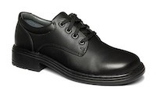 |  | 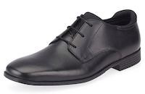 |  | 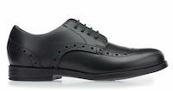 |  | 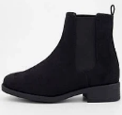 | 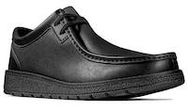 |  |  | 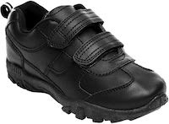 | 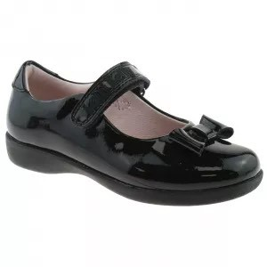 |  |  | 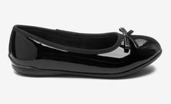 |  | 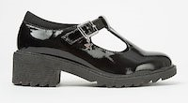 |  |  | 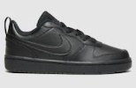 | 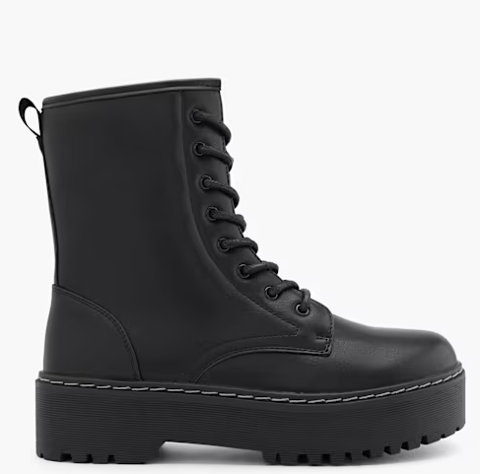
 |  |  |  | Patent |  | Ankle boots | Slip on |  |  | Velcro |  |  |  |  |  | Black heel under 3cm |  |  | Air Force 1 (minus silver tag) | Plain black boots
 | Unacceptable Shoes- Soft-topped trainers, Vans or canvas shoes/daps are not permissible. No coloured laces. No excessive adornments to shoes or boots.
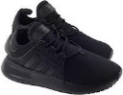 |  | 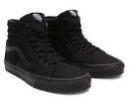 |  | 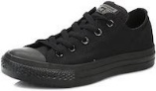 |  | 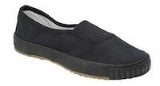 | 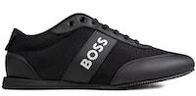 |  |  | 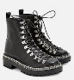 | 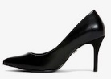 |  |  | 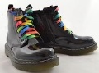 |  | 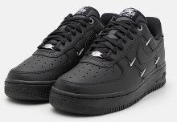
Canvas  Trainers |  | Vans |  | Converse |  | Canvas shoes/ daps | Branded |  |  | Excessive adornments | Heels above  3cm |  |  | Coloured laces |  | Tags
 | Acceptable Trousers/Shorts/Skirts - Black Trousers – straight leg style. Plain black shorts - tailored, knee length. Black skirt – Henley style.
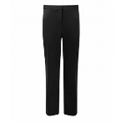 |  | 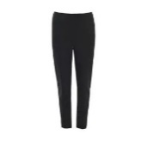 | 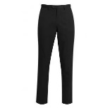 |  | 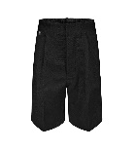 |  |  | 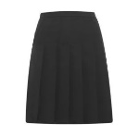 | 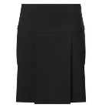
Straight legged |  |  |  |  | Smart, tailored shorts |  |  | Pleated skirt | Large pleats
 | Unacceptable Trousers/Shorts/Skirts - Skinny or jeans style, jeans and leggings are not acceptable. Trousers should be full length and reach the shoe. No tight, low fitting or cargo style shorts permitted. Skirts must cover at least two thirds of the upper leg.
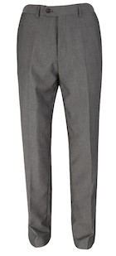 |  | 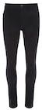 | 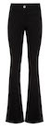 |  | 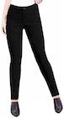 |  |  | 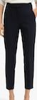 | 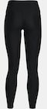 |  |  | 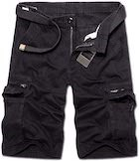 | 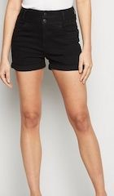 |  | 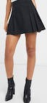 |  |  | 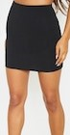
Wrong colour |  | Jeans | Flares |  | Too tight |  |  | Cropped | Leggings |  |  | Cargo shorts | Too short |  | Too short |  |  | No pleats/too  short/too tight

